PROJECT REPORT
ON
Institute Management portal

INTRODUCTION -:

This project is for controlling the management of a institution. Now a days it is difficult to control a data of a institute such as
Student details, Teacher details , payment details and also timetable. If we have a website to control that activities then is can be more helpful to us.

Product Characteristic -:

Through this website we can –
- Resister to the student.
- Login to student.
- We can get time table of courses availabilities.
- We can find to the institute through map.
- Feedback to the institution.

Architecture -:
It based on python Django MVT Architecture. MVT stands for Model-Tiew-Template.
- Model-:Model is a class which is used control Database table.
- View -: it is a python function It is used for get the request from end user and execute the action and give response to the end user through the template.
- Template -: Templates in djangoA Django template is a text document or a Python string marked-up using the Django template language. Some constructs are recognized and interpreted by the template engine.
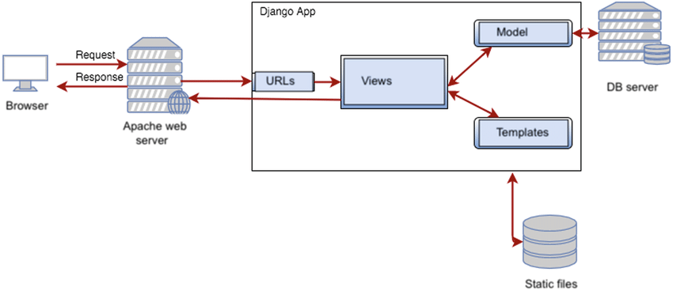

Software Requirment:

- Python 3.10.7
- Django 4.1.1
- HTML
- CSS
- JavaScript

ROLE:
On that project I have developed Model,view,And url,And template part.

